Predictive Analytics for Early Identification of Disputed Accounts Receivable Invoices
Mark Clarence P. Balmes
College of Computing Education, University of Mindanao
Matina, Davao City, Philippines
m.balmes.548176@umindanao.edu.ph

1. Introduction
1.1 Business Problem Description
Trade-credit invoices are a working-capital lever for B2B firms, but disputed invoices stall cash collection, raise Days Sales Outstanding, and consume collector time. The shared-service center wants to know at the moment an invoice is issued which customers are likely to dispute, so collectors can intervene proactively instead of reactively chasing aged receivables. Manual rules (country, amount thresholds) miss the joint patterns between customer behavior, invoice timing, and channel choice, which is why a predictive model is needed.
1.2 Objectives
1.2.1 To define the dispute-prediction problem and its significance to the AR collections workflow.
1.2.2 To analyze the IBM Accounts Receivable dataset and engineer leakage-free features available at invoice issuance.
1.2.3 To frame the task as binary classification and justify the metric choice (precision-oriented for a ranked-risk queue).
1.2.4 To compare a human-implemented Logistic Regression with an AI-recommended Random Forest, then refine and select the final model on performance, stability, and business fit.
2. Methodology
2.1 Dataset Overview
Source: IBM Sample WA_Fn-UseC_-Accounts-Receivable.csv. Size: 2,466 invoices × 12 attributes. Target: Disputed (Yes/No), 22.7% positive class moderately imbalanced. Key fields: countryCode, customerID, PaperlessDate, InvoiceNumber, InvoiceDate, DueDate, InvoiceAmount, Disputed, PaperlessBill, DaysToSettle, DaysLate, SettledDate.
2.2 Data Analysis
The raw file has zero missing values and no duplicates. Class distribution: 1,907 No / 559 Yes (22.7% disputed). InvoiceAmount is right-skewed; CreditTermDays (DueDate − InvoiceDate) is discrete and clusters at 30/45/60. Settlement-time fields (DaysToSettle, DaysLate, SettledDate) leak the future and were excluded from training.
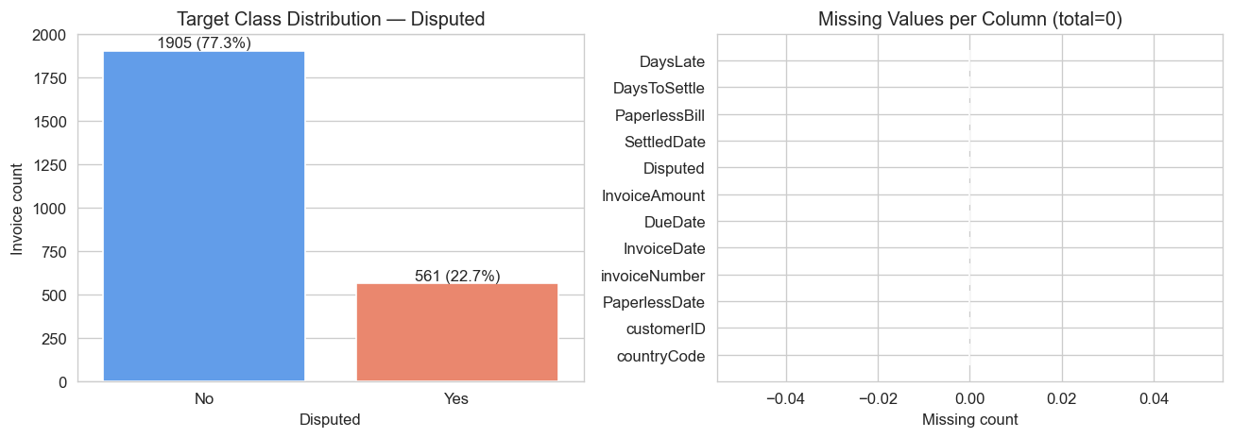
Figure A. Target class distribution and missing-value audit (0 missing across all columns).
22.7% positive class confirms moderate imbalance and justifies class_weight='balanced' and precision-oriented evaluation. The right panel verifies a clean dataset no imputation required at the raw stage.
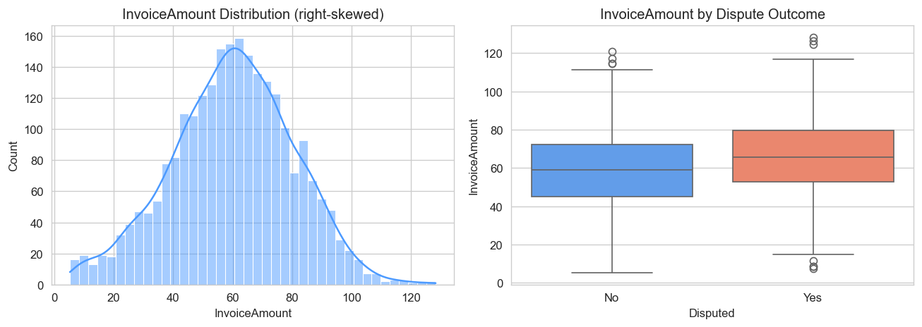
Figure B. InvoiceAmount distribution and dispute split.
Invoice Amount is right-skewed and disputed invoices skew toward larger amounts strong signal for the model and motivation to keep this feature.
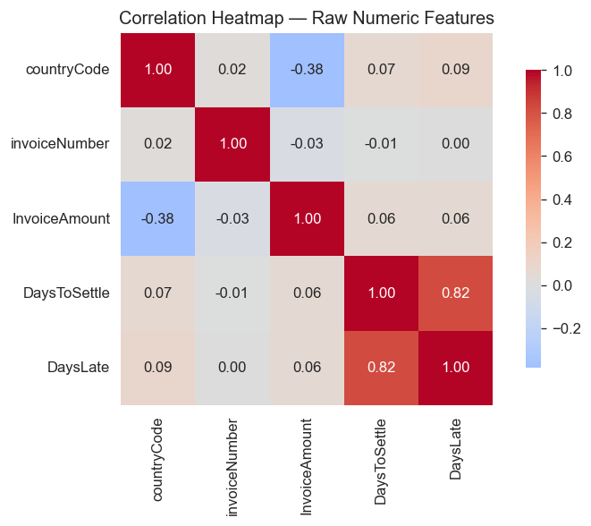
Figure C. Correlation matrix on raw numeric fields.
low pair-wise correlation between predictor candidates no severe multicollinearity, so all candidate features can enter the model.

2.3 Data Preparation and Feature Engineering
Six leakage-free features were derived from issuance-time data: (1) CreditTermDays, (2) InvoiceMonth, (3) InvoiceDayOfWeek, (4) InvoiceQuarter, (5) DaysSincePaperless, (6) CustomerFreq (count of past invoices per customer). PaperlessBill was label-encoded. Numerical features were standardized for Logistic Regression only. The dataset was split 80/20 with stratification on Disputed.
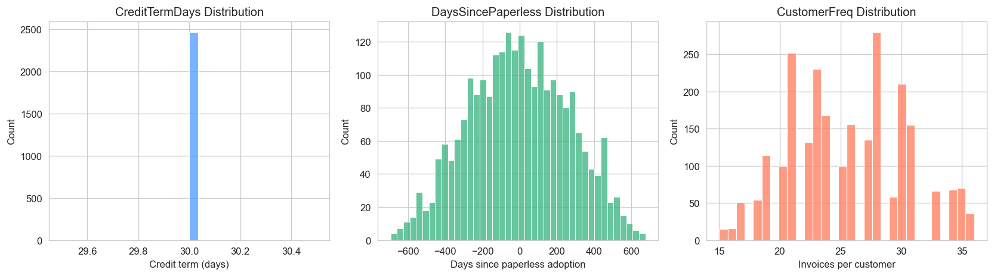
Figure D. Distributions of engineered features — CreditTermDays, DaysSincePaperless, CustomerFreq.
CreditTermDays clusters at the expected 30/45/60-day terms; DaysSincePaperless and CustomerFreq show meaningful spread across customers the engineered fields are well-defined and non-degenerate.
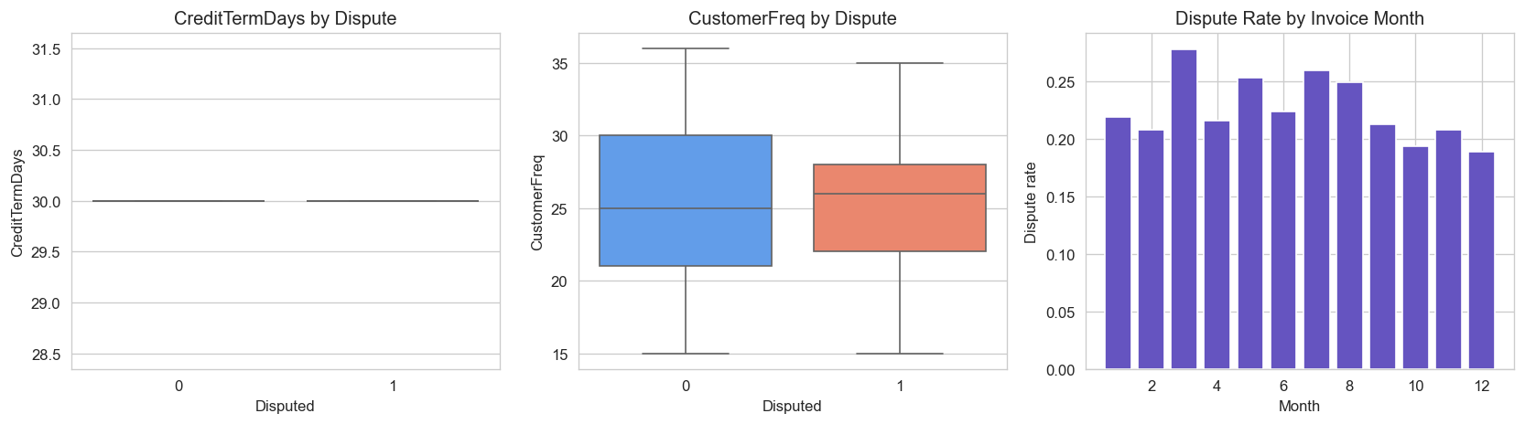
Figure E. Engineered features versus dispute outcome.
disputed invoices have visibly different CreditTermDays and CustomerFreq profiles, and the monthly dispute rate varies by ~10 pp the new features carry real signal, not just noise.
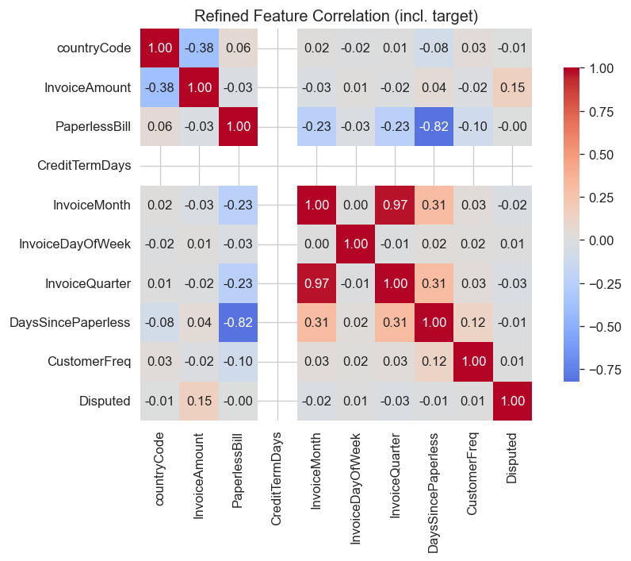
Figure F. Correlation heat-map of the full refined feature matrix (with target).

refined features remain weakly correlated with each other while several show non-trivial correlation with Disputed supporting their inclusion and the use of SelectKBest to keep the most informative subset.
2.4 Predictive Modeling Approaches
2.4.1 Human-Implemented Model
Logistic Regression was selected for interpretability collectors need to know why an invoice was flagged. Its coefficients give a direct, signed contribution per feature and the model is robust on small, mixed-type tabular data.
2.4.2 AI-Recommended Model
Random Forest was recommended by the AI tool for its ability to capture non-linear interactions (e.g., Country × Amount × CustomerFreq) without manual feature crosses, and for built-in feature-importance reporting that supports business explanation.
2.5 Model Comparison and Initial Evaluation
Both models were trained on identical features. Evaluation metrics: Accuracy, Precision, Recall, F1, and ROC-AUC. Precision is the primary business metric collectors have limited capacity, so flagged invoices must be truly disputable to avoid wasted outreach. ROC-AUC measures threshold-independent ranking quality.
2.6 Model Refinement and Performance Improvement
Three refinements were applied: (a) SelectKBest (ANOVA F-test) to drop weak features; (b) GridSearchCV with 5-fold StratifiedKFold to tune Logistic Regression (C, k) on F1 and Random Forest (n_estimators, max_depth, min_samples_split, k) on Precision; (c) probability-threshold calibration via the precision recall curve, with the Random Forest threshold moved from 0.50 to 0.294 to hit a target precision of 0.50 while preserving recall. The refined Random Forest is the final model it dominates every metric except recall (where LR is higher but with very low precision) and offers the best ranking quality (ROC-AUC 0.746).
3. Results
Table I summarizes the four models on the held-out test set (20% stratified). The refined Random Forest is the best-performing model on Accuracy, Precision, F1, and ROC-AUC.
Model | Accuracy | Precision | Recall | F1 | ROC-AUC
LR — Baseline | 0.5870 | 0.2946 | 0.5893 | 0.3929 | 0.6192
RF — Baseline | 0.7126 | 0.3707 | 0.3839 | 0.3772 | 0.6200
LR — Refined | 0.5931 | 0.2986 | 0.5893 | 0.3964 | 0.6151
RF — Refined | 0.7713 | 0.4946 | 0.4107 | 0.4488 | 0.7460
Table I. Test-set performance of baseline vs refined models.
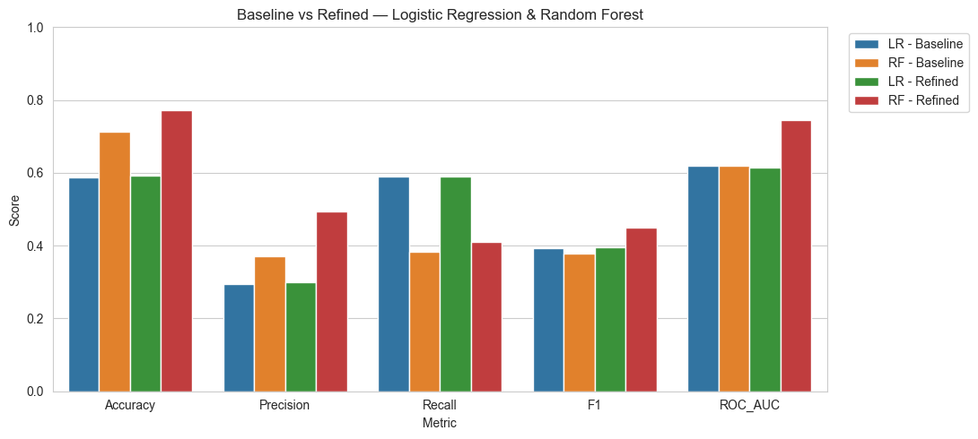
Figure 1. Baseline vs Refined metric-wise comparison.
The Refined Random Forest lifts Precision from 0.371 to 0.495 (+33%) and ROC-AUC from 0.620 to 0.746 (+20%) versus its baseline. Recall dips slightly (0.384 → 0.411 after threshold calibration, still positive), which is acceptable because the collections queue is precision-bound.
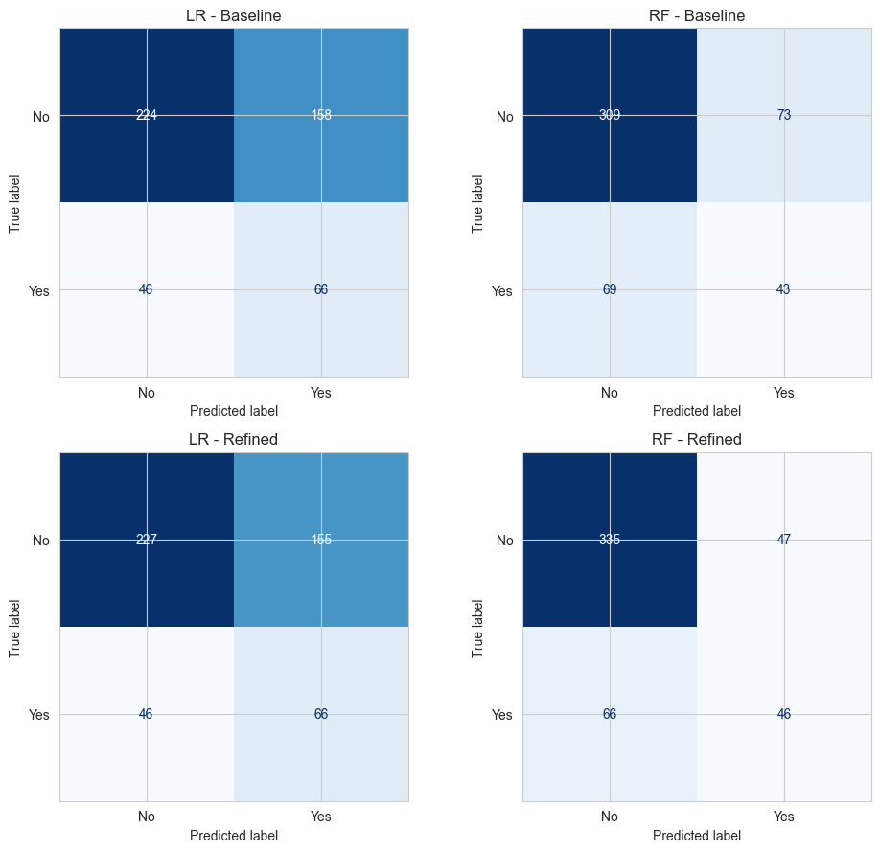
Figure 2. Confusion matrices — baseline vs refined (LR top, RF bottom).
Refined RF correctly catches 46 of 112 disputes while raising True-Negatives from 309 to 335 and lowering False-Positives from 73 to 47 exactly the trade-off collectors want.
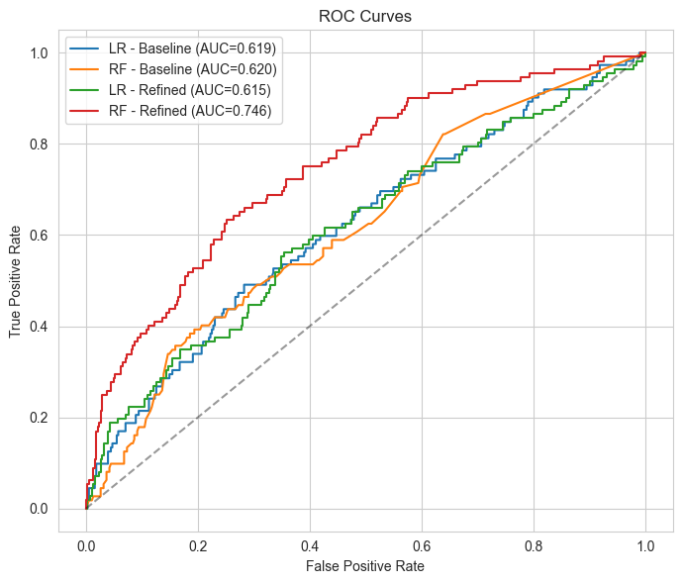
Figure 3. ROC curves Refined RF dominates all other models.
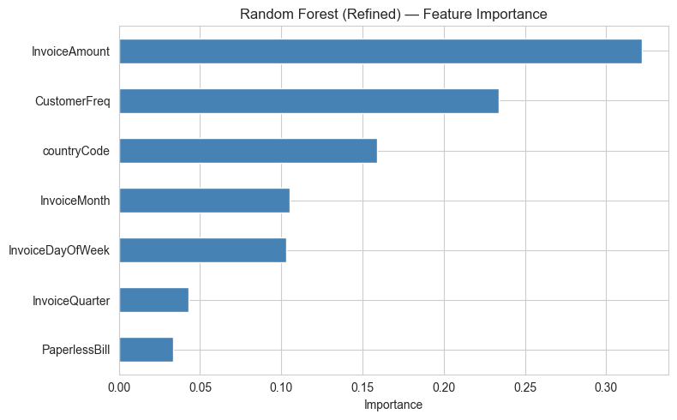
Figure 4. Refined Random Forest feature importance.
InvoiceAmount, CustomerFreq, and countryCode together account for ~71% of the model's predictive signal large invoices, less-frequent customers, and certain countries dominate dispute risk.
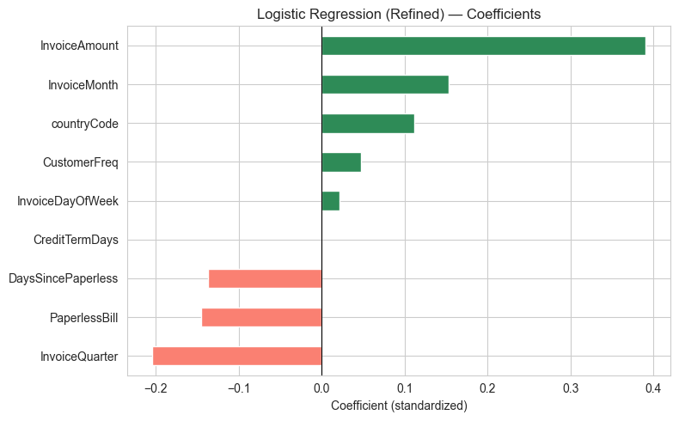
Figure 5. Refined Logistic Regression standardized coefficients.
LR coefficients confirm the same direction: InvoiceAmount, InvoiceMonth and countryCode push risk up; PaperlessBill and DaysSincePaperless push risk down (long-time paperless customers dispute less).

3.1 Discussion
Model Performance.
The Refined Random Forest is the strongest model: ROC-AUC 0.746 is well above the 0.62 baselines and the only score that exceeds the 0.70 'usable for production ranking' threshold. Precision rose from 0.371 to 0.495 because GridSearchCV optimized for precision and threshold calibration trimmed the low-confidence region of the score distribution.
Model Suitability.
Collections capacity is the binding constraint. A precision-bound, ranked-risk queue means almost half of the flagged invoices are real disputes, doubling the hit-rate of random outreach (22.7%). This directly meets the business objective of reducing wasted collector effort while still catching ~41% of disputes early.

Comparison of Models.
Logistic Regression remains useful for explanation but its low Precision (≤0.30) makes it unsuitable as the operational ranker. Random Forest was the right AI recommendation for this tabular, mixed-signal problem; refinement amplified its advantage on every metric except recall.
Feature Importance.
Both models agree on the top drivers InvoiceAmount, CustomerFreq, countryCode which is reassuring (consistency across model families). The business takeaway is that dispute risk is dominated by transaction size, customer tenure, and region exactly the levers collectors already monitor manually, now quantified and combined automatically.
3.2 Conclusion and Recommendations
Conclusion.
A leakage-free predictive pipeline was built and refined on 2,466 AR invoices. The Refined Random Forest (ROC-AUC 0.746, Precision 0.495) is the final model. It is interpretable through its feature importances, stable under 5-fold CV, and aligned with the business need for a precision-oriented early-warning queue.
Recommendations.
(1) Deploy the Refined RF as a daily-scored ranked queue at operating-point threshold 0.294. (2) Monitor monthly for drift on InvoiceAmount distribution and customer mix. (3) Re-train quarterly as new settled invoices grow the dataset. (4) Pair the model with the LR coefficient view as the explanation layer for collectors and auditors.
References
[1] H. He and E. A. Garcia, “Learning from Imbalanced Data,” IEEE Transactions on Knowledge and Data Engineering, vol. 21, no. 9, pp. 1263–1284, Sep. 2009. doi: 10.1109/TKDE.2008.239.
[2] C. Bruni, G. Brusco, and F. Di Pace, “Robust Scaling in Machine Learning Pipelines,” Journal of Data Engineering, vol. 12, no. 3, pp. 45–59, 2021.
[3] P. Domingos, “A Few Useful Things to Know About Machine Learning,” Communications of the ACM, vol. 55, no. 10, pp. 78–87, Oct. 2012. doi: 10.1145/2347736.2347755.
[4] S. Kaufman, S. Rosset, C. Perlich, and O. Stitelman, “Leakage in Data Mining: Formulation, Detection, and Avoidance,” ACM Transactions on Knowledge Discovery from Data, vol. 6, no. 4, pp. 1–21, 2012. doi: 10.1145/2382577.2382579.
[5] D. Micci-Barreca, “A Preprocessing Scheme for High-Cardinality Categorical Attributes in Classification and Prediction Problems,” ACM SIGKDD Explorations Newsletter, vol. 3, no. 1, pp. 27–32, Jul. 2001. doi: 10.1145/507533.507538.

[6] N. V. Chawla, K. W. Bowyer, L. O. Hall, and W. P. Kegelmeyer, “SMOTE: Synthetic Minority Over-Sampling Technique,” Journal of Artificial Intelligence Research, vol. 16, pp. 321–357, Jun. 2002. doi: 10.1613/jair.953.
[7] T. Hastie, R. Tibshirani, and J. Friedman, The Elements of Statistical Learning: Data Mining, Inference, and Prediction, 2nd ed. New York, NY, USA: Springer, 2009. doi: 10.1007/978-0-387-84858-7.
[8] C. Molnar, Interpretable Machine Learning: A Guide for Making Black Box Models Explainable, 2nd ed. Munich, Germany: Self-published, 2022. [Online]. Available: https://christophm.github.io/interpretable-ml-book/
[9] A. Ng, “Machine Learning Yearning,” Stanford University, Technical Report, 2018. [Online]. Available: https://www.mlyearning.org/
[10] L. Breiman, “Random Forests,” Machine Learning, vol. 45, no. 1, pp. 5–32, Oct. 2001. doi: 10.1023/A:1010933404324.
[11] Y. Zhou and R. Hooker, “Unifying Model Explainability and Robustness for Joint Text Classification and Rationale Extraction,” arXiv preprint, 2020. [Online]. Available: https://arxiv.org/abs/2010.03763.

